WEEK #3
1# A bookstore’s billing app needs a quick utility script. Write a Python program that reads N integers (prices) and computes: i) SUM ii) PRODUCT iii) AVERAGE
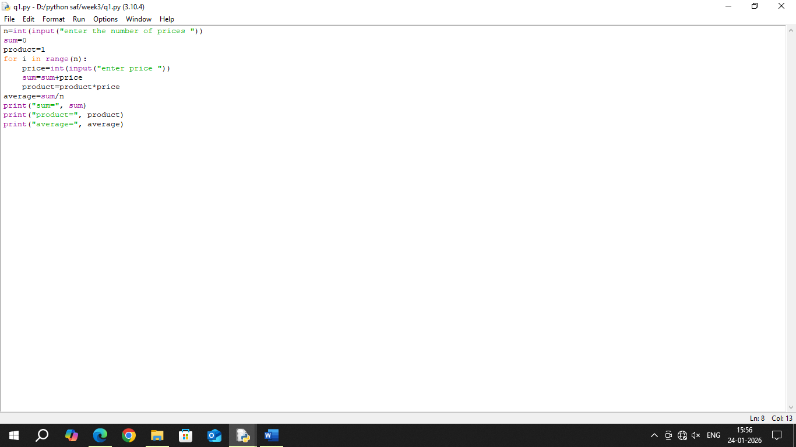
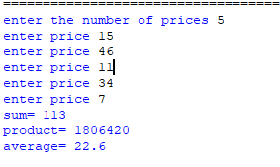
2# A weather station needs temperature conversion. Write a program to convert Celsius to Fahrenheit. (Celsius values can be fractional.)
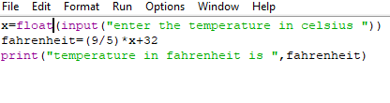
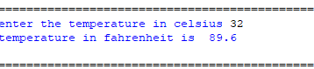
3# An architecture tool calculates dimensions. Write a program to compute the Surface Area and Volume of a Cuboid given length, breadth, height.
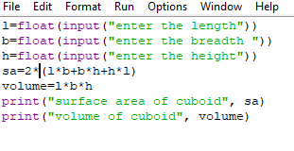
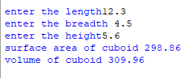
4# Write a program to add two numbers without using arithmetic operators, using bitwise operators.
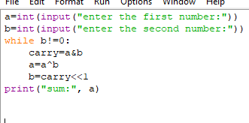
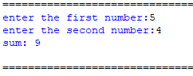
5# A hardware technician tests divider circuits. Read an integer and divide it by 4 using the bitwise >> operator.
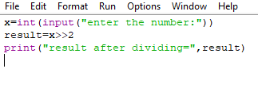
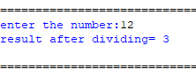
6# A robotics controller swaps sensor IDs efficiently. Read two integers and exchange their values using XOR (^) operator.
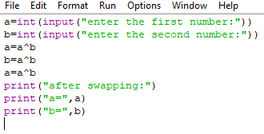
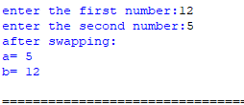
7# A gaming console optimizes score calculation. Multiply a number by 10 using bitwise operators.
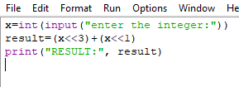
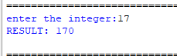
8# A data-logging device swaps configuration settings. Read two integers and exchange their values using addition and subtraction (avoid using a third variable).
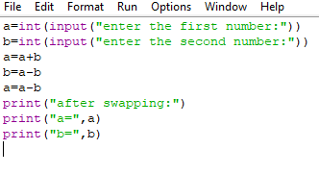
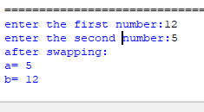
9# A biology simulation needs repeated multiplication. Write a program to compute the factorial of an integer using a loop
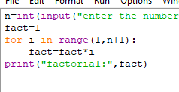
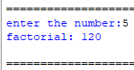
10# A math module checks sequence validity. Write a program to determine whether a number is a Fibonacci number.
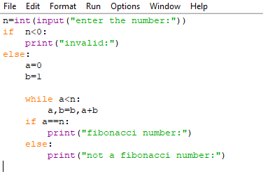
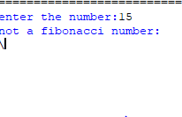
11# A security system verifies prime-number-based keys. Write a program to check whether an integer is prime, or else output its first factor.
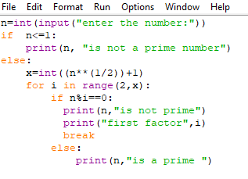
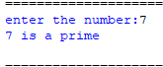
12# A signal-processing unit finds harmony between two frequencies. Write a program to compute the GCD of two numbers.

